**Ondare honen azalpenaren ondoren hiru botoi agertuko dira errazenetik zailenera honen inguruko jarduera batzuk egiteko. Jarduera hauek puzzleak egiten datza eta, horretarako, programa baten laguntzaz baliatu gara puzzleak sortzeko. Hori dela eta, Html kodigoak atxikiko ditugu. Zuen baliorako izan dadila espero dugu.**

**Enuntziatua**: “Elizaren puzzleak osatu eta puzzle bakoitza amaitzean argazki originala bilatu.”

**Lehenengo puzzlea (erraza).jpeg**:

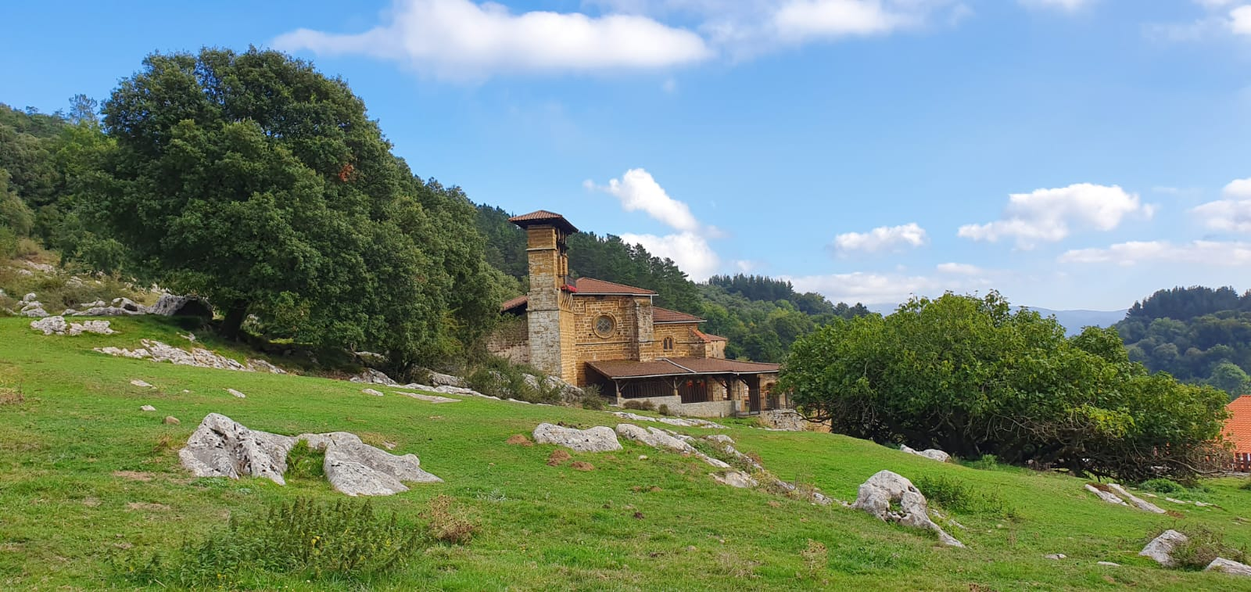

**Lehenengo puzzlearen kodigoa**:

<span title="Ermuko Andra Mari Eliza - Erraza - online jigsaw puzzle - 8 pieces" style="display:inline-block;margin:.6em;width:160px"><a href="https://www.jigsawplanet.com/?rc=play&amp;pid=2754f0a05473" style="display:block;text-decoration:none;position:relative;width:160px;margin:0 auto .4em auto"><img alt="preview" style="display:block;border:1px #000 solid;box-shadow:2px 2px 5px rgba(0,0,0,.2)" src="https://im.jigsawplanet.com/?rc=img&amp;pid=2754f0a05473&amp;size=160"><span style="position:absolute;right:5px;bottom:4px"><span style="font:bold 120% Verdana,sans-serif;color:#fff;text-shadow:1px 1px 2px #000;vertical-align:middle">8 </span><img style="border:0;vertical-align:middle" src="https://www.jigsawplanet.com/img/preview/piece.png" alt="piece"></span></a><a style="display:block;text-align:center;overflow:hidden" href="https://www.jigsawplanet.com/?rc=play&amp;pid=2754f0a05473">Ermuko Andra Mari Eliza - Erraza</a></span>

**Bigarren puzzlea (normala).jpeg**:

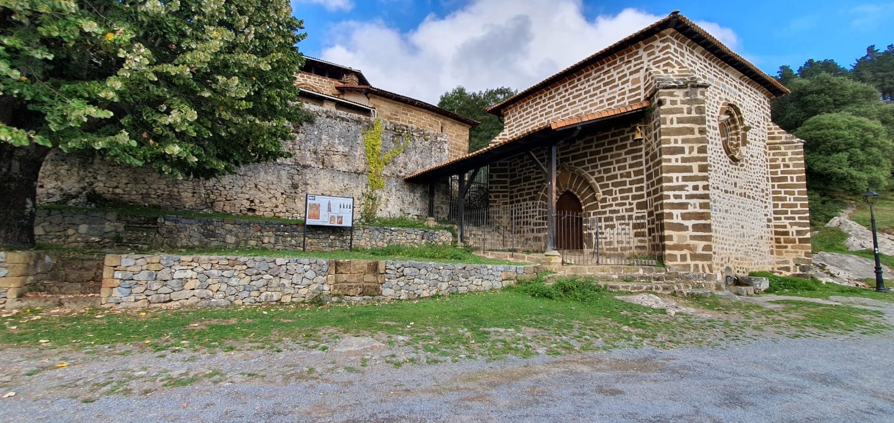

**Bigarren puzzlearen kodigoa**:

<span title="Elizaren bigarren puzzlea - Normala - online jigsaw puzzle - 21 pieces" style="display:inline-block;margin:.6em;width:160px"><a href="https://www.jigsawplanet.com/?rc=play&amp;pid=3b7037915d0f" style="display:block;text-decoration:none;position:relative;width:160px;margin:0 auto .4em auto"><img alt="preview" style="display:block;border:1px #000 solid;box-shadow:2px 2px 5px rgba(0,0,0,.2)" src="https://im.jigsawplanet.com/?rc=img&amp;pid=3b7037915d0f&amp;size=160"><span style="position:absolute;right:5px;bottom:4px"><span style="font:bold 120% Verdana,sans-serif;color:#fff;text-shadow:1px 1px 2px #000;vertical-align:middle">21 </span><img style="border:0;vertical-align:middle" src="https://www.jigsawplanet.com/img/preview/piece.png" alt="piece"></span></a><a style="display:block;text-align:center;overflow:hidden" href="https://www.jigsawplanet.com/?rc=play&amp;pid=3b7037915d0f">Elizaren bigarren puzzlea - Normala</a></span>

**Hirugarren puzzlea (zaila).jpeg**:

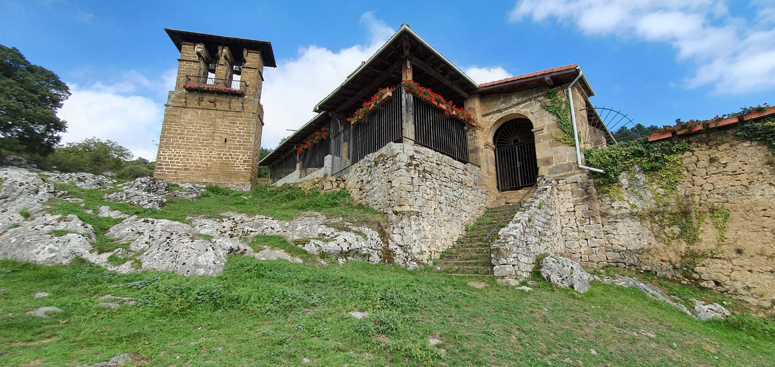

**Hirugarren puzzlearen kodigoa**:

<span title="Elizaren hirugarren puzzlea - Zaila - online jigsaw puzzle - 32 pieces" style="display:inline-block;margin:.6em;width:160px"><a href="https://www.jigsawplanet.com/?rc=play&amp;pid=24b45a9b0a4d" style="display:block;text-decoration:none;position:relative;width:160px;margin:0 auto .4em auto"><img alt="preview" style="display:block;border:1px #000 solid;box-shadow:2px 2px 5px rgba(0,0,0,.2)" src="https://im.jigsawplanet.com/?rc=img&amp;pid=24b45a9b0a4d&amp;size=160"><span style="position:absolute;right:5px;bottom:4px"><span style="font:bold 120% Verdana,sans-serif;color:#fff;text-shadow:1px 1px 2px #000;vertical-align:middle">32 </span><img style="border:0;vertical-align:middle" src="https://www.jigsawplanet.com/img/preview/piece.png" alt="piece"></span></a><a style="display:block;text-align:center;overflow:hidden" href="https://www.jigsawplanet.com/?rc=play&amp;pid=24b45a9b0a4d">Elizaren hirugarren puzzlea - Zaila</a></span>

**Hau da erabilitako link-a edo programa puzzleak osatzeko:** <https://www.jigsawplanet.com/>